**Intelligent Systems**

**Exercise 6.** **Games and Adversary Search**

# Exercise description

The objective of this exercise is to practice the knowledge about the topic of games and adversarial search.

**Team members**

Write the student id, name, and campus of each member in a different line.

1:

2:

3:

1. Find the **MINIMAX decision** in the following game tree by applying the minimax algorithm with alpha-beta pruning. In addition, it is expected that in the tree and for each interior node you show the MINIMAX value, the alpha value, and the beta value.

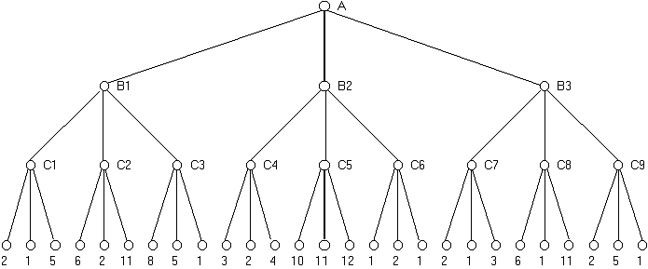

1. Design a reasonable heuristic evaluation function for the classic board game of **Nine men’s Morris**, mentioning the **characteristics** (good and bad) that you would take into account and how you would **calculate** them (transform the characteristics to numbers) from the description of the state of the game. **Justify** your design decisions.

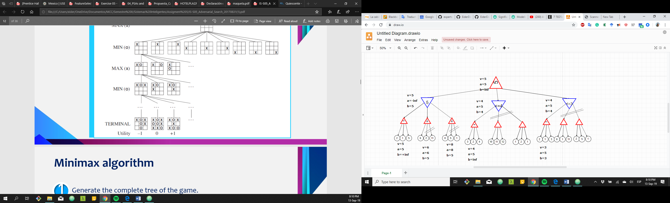

Nine men’s Morris is believed to have been played in the Roman Empire. It is also referred to as nine-man Morris, mill, mills, the mill game, merrills, ninepenny marl and “cowboy checkers” (it was often printed on the back of checkerboards).

***Game basics***

The game starts with an empty board as the following:

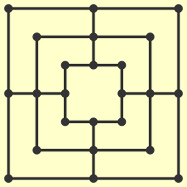

Then, the players place all their pieces (MEN), one by one, on board and aim to move them to form a line of 3 pieces (a MILL).

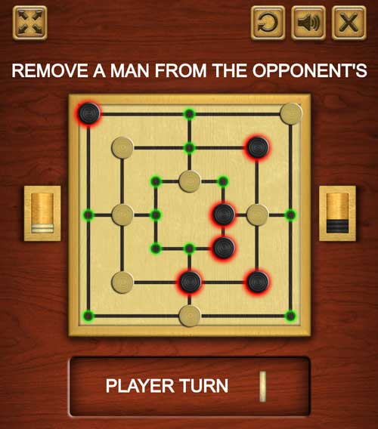

Once a mill is formed, the player can remove one of its opponent’s men and after that, the mill is locked. Break a mill, by moving one of its men, to unlock the mills gain. Pieces from a formed mill cannot be removed unless no other men are available.

Either the aim is to leave the opponent with 2 pieces or zero moves left to win the game.

You can try the game in <https://playpager.com/mill-game/>

1. Enumerate at least 3 relevant features of the game that can be used to construct the heuristic evaluation function for the game.
2. Write a formula for your evaluation function
3. Evaluate the following boards using your evaluation function. Show the evaluation of each feature.

**Board 1 Board 2**

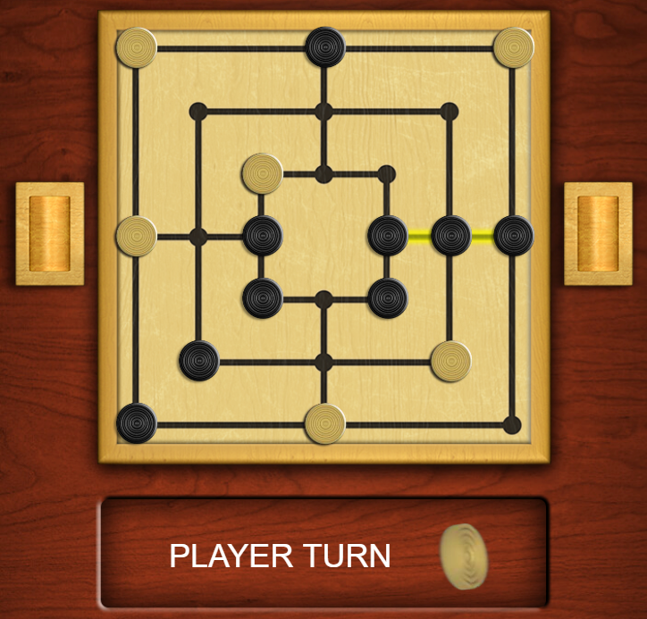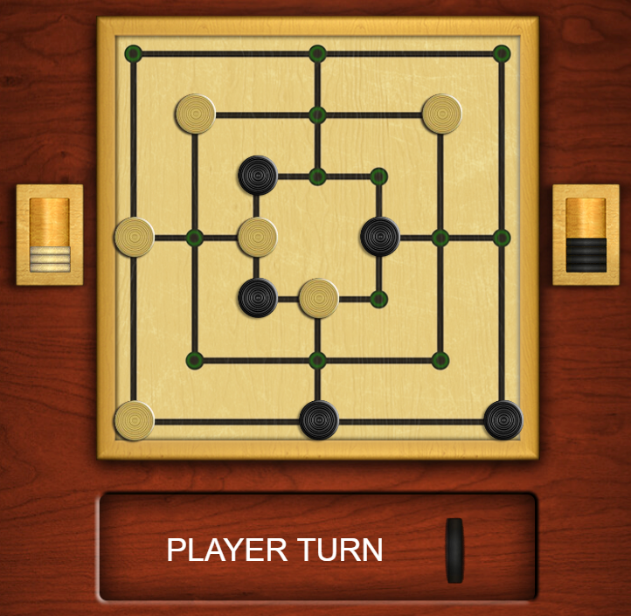

**Board 3**

